# Problem Statement/Summary

<WIP> Lilypad Aerospace as an aerospace organization will be expected to track and orient various devices at airborne payloads. This document serves as an explanation of Lilypad Aerospace’s needs, and a collection of justified requirements. This could be for the purposes of mission operation, recreation, or media/marketing. In any case there is a need for a robotic manipulator that can point objects highly accurately at other objects. Tracking and pointing mechanisms are not uncommon in the industry so much is known about the topic, but because many of the existing technologies require precision devices and manufacturing it is very expensive to purchase a pointing device; and it would be even more expensive to purchase a device for only one use-case. Therefore, a dedicated project is being spawned by Lilypad Aerospace to produce a tracking and pointing mechanism. Various potential use cases are being analyzed for the requirements study. The project will be deemed “Frog Brain”. Frog Brain is expected to be designed and built in house to optimize for Lilypad Aerospace’s needs with respect to cost; but it is perfectly feasible to find a commercial-off-the-shelf (COTS) option already being sold if it fits all of the listed requirements and is not expensive.

There are many pointing mechanisms in use in the industry today and inspiration is not in short supply. There may some day be a need for a system which is designed to point at distant objects from an unstable platform (such as a camera on an airplane looking at the ground); but for now, the scope of this project will be limited to the assumptions of a grounded platform. This limits the use cases of Frog Brain to ground stations. Requirements will be written in accordance with this, apart from mounting Frog Brain to the roof of a car as a mobile ground station. Some examples of ground station pointing mechanisms are shown below.

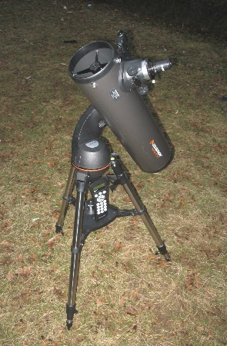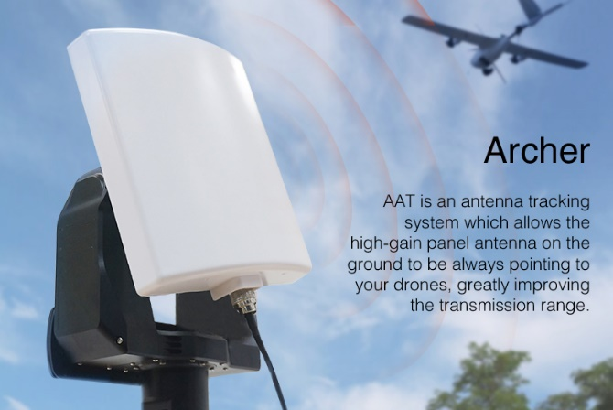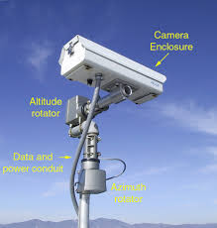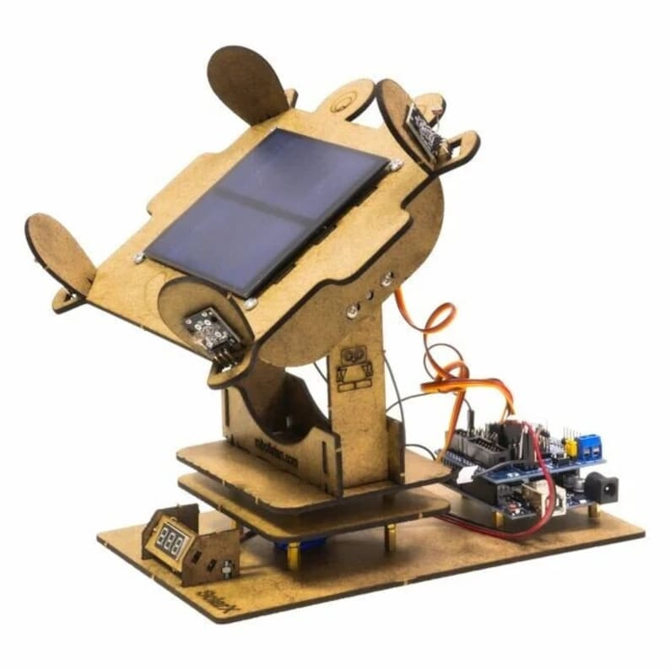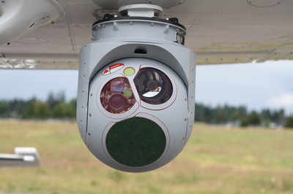

This document does not serve to set expectations for the design of Frog Brain, but from industry standard examples it is fair to assume an expected top-level design. Frog Brain will likely consist of the following sub-systems listed below. Note that project Frog Brain is not responsible for designing the payloads which will be pointed, and instead is only providing a semi-universal mounting platform with some example cases in mind. It is up to field application engineers using Frog Brain to design and manage the mounting of payloads to the Frog Brain mechanism in an intelligent and suitable way to support whatever mission Frog Brain is being used on.

1. Payload – Whatever device is to be pointed (not to be designed under this project)
2. Carriage – The mechanical interface where payloads will attach to. Also serves as the origin of the pointing reference frame axis.
3. Az-El mechanism – The assembly of mechanical components which serve to contain and transfer actuator inputs into rotations.
4. Electronics – Motors, cables, driver boards, and other electronics used for driving the robotics. This includes any smart sensors and encoders.
5. Computer – The software and hardware converting pointing commands into electronics signal inputs.

# Requirements List

|  |  |  |
| --- | --- | --- |
| # | Sec. | Description |
| 1 | A | Carriage should be able to perform all of the below requirements with a mounted device of mass <> and a maximum MOI of <>. |
| 2 | B | Carriage must be able to obtain a maximum of 374 deg/sec of slew in any direction with an allowed 0.25 second acceleration from rest period. |
| 3 | B | Carriage must have an at-rest positional accuracy of +/- 0.00014 degrees |
| 4 | C | Frog Brain must be able to operate somewhat continuously in ambient temperatures of -5 to 40 Celsius. |
| 5 | C | Frog Brain must be able to operate somewhat continuously in humidity up to 50% |
| 6 | C | Frog brain must be at least IP 57 tolerant |
| 7 | C | Frog brain must be buoyant in water |
| 8 | C | Enclosures used to provide IP protection should be at least IK <> rated. |
| 9 | D | Frog Brain must be able to operate continuously under random vibrational noise as depicted in Figure 2. |
| 10 | D | Frog brain must be able to survive a drop from 2 meters (6.26 m/s at impact) onto asphalt. |
| 11 | E |  |

# Derivation Of Requirements

## Section A: Mounted Payloads

An unknown number of objects could be used on this device and generalized mass and moment of inertia properties must be selected in a generalized yet rational function. Various large potential candidates for mounted payloads are shown below. These candidates include a camera for close to medium range video capture, a telescope for video capture and observation of distant objects, a medium sized Yagi antenna for directional communications, and a medium sized 50-watt solar panel for power collection. These candidates represent a variety of (but not conclusive or complete list of) different applications and the respective payloads that would be used for such applications. The selection of these specific candidates was performed with subject matter expert advice.

**Figure 1B: Celestron telescope tube (mounted off axis)**

**Figure 1C: VHF Yagi antenna**

**Figure 1D: 50 watt 12 volt solar panel**

A table of estimated or provided mass and inertia properties for all objects is shown below. The estimated values were created using generic physics equations and uniform mass distribution assumption. The location of the axis for the greatest moment of inertia was assumed to pass through the presumed mounting location of the candidate.

**Table 1: Payload candidates**

|  |  |  |
| --- | --- | --- |
| Payload | Mass | greatest MOI |
| Camera |  |  |
| Telescope | 4.3 kg | 0.0316 kg-m^2 |
| antenna | 5 kg | 4.177 kg-m^2 |
| Solar panel | 3.5 kg | 0.098 kg-m^2 |

The largest values for both mass and moment of inertia, plus an arbitrarily chosen 15% factor of safety is used as the requirements for the payload compatibility. These values are *INSERT VALUES HERE*. We can add an arbitrary 15% factor of safety and thus the mass and moment of inertia expectations are *INSERT VALUES HERE*, respectively.

## Section B: Slew Rates and Position Accuracies

For any practical application, Frog Brain will need to satisfy the orientation and slew rate accuracies in order to properly direct the payload. Positional accuracy is typically associated with long distance observation and slow slew rates. Slew rate is typically defined as a maximum value and assumed to be continuous and not jittery. We can start by selecting the maximum distance for our tracker to expect to track something. A good metric for determining this is altitude and elevation, assuming the tracker is kept to the ground. Frog brain is intended to track aerospace objects primarily, so this is a fitting distance derivation. But different objects require different levels of accuracy, for example, recording an aircraft requires a zoomed in camera with very high accuracy and is relatively close, as little as 5,000 ft away, whereas pointing an antenna at a spacecraft can allow for up to many degrees of inaccuracy, but satellites are many kilometers away. Listed below are various trackable examples, their assumed minimum elevation, and approximate altitude. These values are derived by the author’s personal expertise and/or low intensity research.

**Table 2: Angle accuracy driving scenarios**

|  |  |  |  |
| --- | --- | --- | --- |
| Scenario | Max Altitude | Min Elevation | Method of accuracy |
| General aviation tracking | 18,000 ft | 45 deg | Camera frame width |
| Satellite comms | 500 km | 20 deg | Antenna beamwidth |
| Solar tracking | N/A | 20 deg | Small angle theory |
| L3 amateur rocket takeoff | 3,000 ft | 70 deg | Camera frame width |
|  |  |  |  |
| Scenario | Overall distance | Object width | Positional accuracy |
| General aviation tracking | 25,456 ft | 52 ft | 0.00014 degrees |
| Satellite comms | 1,462 km | N/A | 2.50000 degrees |
| Solar tracking | N/A | N/A | 18.0000 degrees |
| L3 amateur rocket takeoff | 3,192 ft | 17 ft | 0.00037 degrees |

$$distance≈ \frac{altitude}{\sin\left(elevation\right)}$$

$$θ=2\tan\left(\frac{2*width}{distance}\right)$$

For camera frame width methods, the approximate size of the object is taken, and it is assumed that the camera zoom is enough to fit 9 of this object in frame. Thus, the camera can be centered on a location within +/- 4 objects distance from the target and still have the entire object within view of the camera.

For antenna beamwidth we simply use the beamwidth of a standard cubesat ground station antenna, no arithmetic needed.

For small angle theory the assumption is that as long as two vectors A and B are within a small angle to each other then the length of projected vector A onto B will be approximately the same magnitude as the parent vector, vector A. if we want to remain within an angle which has a projected magnitude of no less than 95% its parent vector, that corresponds to roughly 18 degrees.

Of the above positional requirements, the most stringent is 0.14 milli-degrees for general aviation tracking. For slew rates we will only determine a maximum target rate, and not a minimum target rate. High slew rates are associated with close and/or high-speed passes by the tracker.

**Table 3: Maximum slew rate scenarios**

|  |  |  |  |
| --- | --- | --- | --- |
| Scenario | Velocity at closest approach | Object closest approach | Slew rate |
| Satellite overhead pass | 7.7 km/sec | 200 km | 2.2 deg/sec |
| General aviation takeoff | 40 m/s | 20 m | 115 deg/sec |
| Balloon payload landing | 5 m/s | 200 m | 1.4 deg/sec |
| L2 amateur rocket ascent | 30 m/s | 4.6 m | 374 deg/sec |

$$slew=\frac{180*vel}{π*r}$$

Satellites usually orbit at approximately 7.7 km/sec in low earth orbit as altitudes ranging from 200 km to about 1,000 km for low earth orbit. A Cessna 172 has a takeoff speed of around 40 m/s, and a reasonable observation distance is from a hangar, just off the taxiway. A balloon payload can be chased and could be seen from any distance, but with good GPS telemetry a 200-meter range is reasonable and a 5 m/s descent rate is also common. Amateur rocketry comes in all shapes and sizes, and technically because the rocket is grounded at closest approach its speed would be zero. Videos of amateur rocketry by the YouTube channel BPS space was used and it was interpreted that maximum slew occurs around the 60 m/s point in the speed profile, so half that value was used. The HARA organization requires that human observation for up to G motors be 30 feet. Higher motor distances were not specified in my source, but I will assume 30 feet since a robot can be closer to a launch than a human.

The result is a maximum slew rate of 374 degrees per second, or just over 1 revolution per second. Angular acceleration values will not be required, instead a simple, arbitrarily chosen acceleration time from rest of 0.25 seconds is selected and may change later.

## Section C: Environmental Survival

The device is expected to be grounded or operated on a stable mobile platform. This can subject the mechanism to various climates, weather, impacts, dust, and wildlife. It is important to define strict survivability and durability requirements so that the mechanism need not be rebuilt every time it is damaged. IP ratings will be defined for the electronics and IK ratings will be defined for any enclosures granting IP rating to enclosed electronics.

Some environmental requirements can be taken from everyday conditions. A standard temperature range can be considered based on the average low and average high of the country. The average lowest yearly temperature in New York is -5 Celsius, and the average yearly hottest temperature in Arizona is 40 Celsius.

Humidity is also important. The ultimate requirement is to avoid the formation of condensation which could lead to electrical short circuiting. Humidity can be combatted in many ways so a tentative requirement to survive up to 50% humidity will be set for now.

IP rating stands for “ingress protection” and is a standardized quantification of how resistant a device or enclosure is to various levels of dust ingress and water ingress. Although “dust ingress” is not as all-encompassing of a description as “solid matter ingress”, because low IP ratings allow for much larger objects than dust to intrude, and middle IP ratings can allow for dust but not some larger solid objects. This can include concerns such as insects, seeds, leaves, and other organic matter that is present in various national sites. Insects and organic matter dictate an IP rating of 4X, however electronics need to be able to withstand a limited amount of dust and dictates and IP rating of 5X. Therefore, all electronics must meet at least IP 5X requirements, and if an enclosure is used to protect against water, it must be at least IP 4X. Dust ingress is not actually difficult to accomplish with enclosures however so it is perfectly reasonable to declare Frog Brain IP 5X required.

The second IP digit is waterproof-ness. At its highest value, level 8, the device should be able to survive high pressure underwater environments which is unnecessary. The worst case scenario is Frog brain being dropped into a lake, or tipping over into a puddle and staying in either state for a long period of time. Assuming Frog Brain is buoyant, this would dictate an IP rating of IP X7, and by extension, buoyancy.

The IK rating system is a standardized method of quantifying an enclosure’s resilience to impacts of various momentum and pressure. IK rating is not a quantification of how resilient an object is to inertial loading, just impacts. It is reasonable that because Frog Brain is expected to be used outside of warehouses and workshops, the heaviest item to create an impact would be Frog Brain itself. The roof of a car is a reasonable height (~ 2 meters), and we can tentatively assume that the heaviest weight of Frog Brain would be around twice the carriage payload mass, or <> kg. This results in <> joules of energy, and an IK rating of <> for all enclosures.

## Section D: Vibration and Inertial Loading

Depending on various circumstances, frog brain could be on stationary ground or on a moving platform. If dropped, Frog Brain needs to withstand some measure of inertial loading to all mounting points. Use on vehicles such as boats or trucks entails some level of vibration resilience as well.

**Figure 2: Typical PSD of a truck bed. Source: Measurement and Analysis of Vibration Levels on Warehouse and Retail Store Material Handling Equipment by Sher Paul Singh.**

Since most vehicle usage can reasonably be assumed to be a car or truck, a simple PSD survival test can be conjured using the above data in Figure 2. Seaborn PSD testing would be different, but because seaborn usage is expected to be uncommon, no seaborn vibration requirements will be mandated for this project.

Inertial loading is the stress felt by components when experiencing acceleration. Most notably, a collision with an object. Most notably, the ground. We can set a drop height expectation similar to section C and calculate a velocity-at-impact with the ground based on gravitational acceleration. This sets our requirement for inertial loading as the precise acceleration to survive will vary wildly based on material used. The expected velocity-at-impact is 6.26 m/s.

## Section E: Electrical and Wire Harnessing

Power and electrical requirements need no justification, but wire harnessing is a necessary feature which needs close mandating due to the simple fact that Frog Brain is a moving, actuating object. Without careful consideration in hardware and/or software the device could twist and tangle itself up into self-damaging knots and catches.

# Revisions

|  |  |  |
| --- | --- | --- |
| Rev code | Description | Date |
| 0.0.0 | Created document | 4/28/2023 |
| 0.1.0 | Core requirements derived and approved for release | 4/29/2023 |
| 0.2.0 | Summary and problem statement section expanded | 4/30/2023 |
| 0.2.1 | Capitalization in section headers | 4/30/2023 |